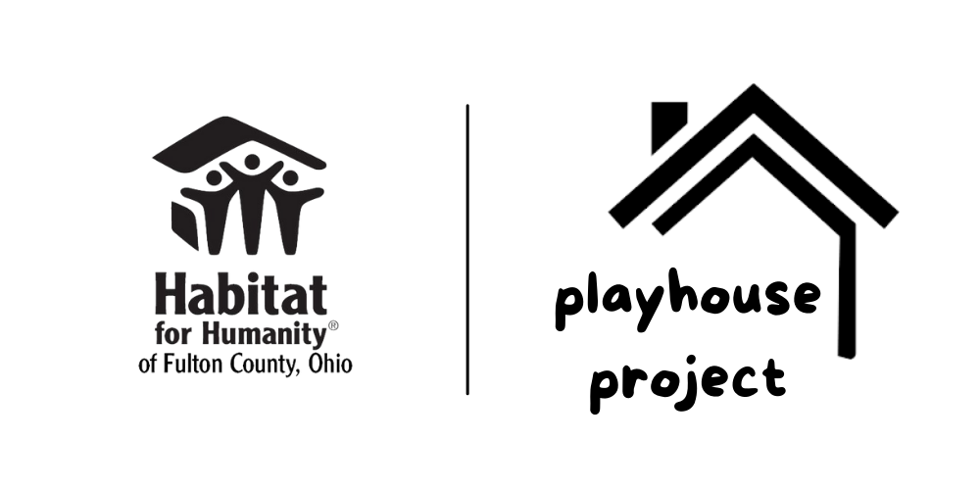

Application and Agreement

Parent/Guardian Information

Name
Phone Number and Email Address:
Street Address, City, State Zip
How did you hear about Playhouse Project?

Tell us about your children so we can build a Playhouse they will love!
Child(ren): Name Age

Will the playhouse require any accessibility modifications? For example, wheelchair access? If yes, please describe.
How would this build a blessing in your child(ren)’s life?

Theme ideas for the Playhouse
What does your child(ren) like so we can include it in the design theme? Characters, letters, numbers, etc. - The more detail, the better! (The playhouse sponsor may incorporate their logo or theme in the design as well)
Child(ren) favorite colors:
Please fill out, sign, and return this agreement if a Playhouse is right for your family.
director@habitatfco.org / 419-335-7000 / PO Box 333, Delta OH 43515

I agree to partner with Habitat for Humanity of Fulton County, Ohio (Habitat) in the following ways:
______ (initial) I agree that I will have my child(ren) at the Playhouse presentation (date/time TBD).
______ (initial) I would not ordinarily be able to purchase a Playhouse for my child(ren).
______ (initial) I agree to pick up the Playhouse. If I am not able to pick up, I will notify Habitat immediately to help make arrangements. *Please note: your Playhouse can not be delivered.
______ (initial) I agree to place a $50 deposit, to be returned upon picking up the playhouse.**
______ (initial) I agree to attend a Playhouse Project orientation meeting. Habitat will reach out to you to schedule.
______ (initial) I give Habitat, its representatives, and Playhouse build sponsors permission to and assign the right to use and reproduce my family and/or child(ren)’s name, image, likeness and/or voice in any and all forms of media including, without limitation, photographs, films, videos, tape recordings, and internet publications. I also authorize Habitat to use and distribute for any and all purposes, letters, stories, testimonials, other writings, quotations or verbal statements attributable to me. I make no further claim of any nature because of or connected with said use of my name, image/likeness, written or verbal statement made by me.
I agree that I understand/confirm the following important information:
______ I understand the size of the playhouse is 4’ wide x 5’ long x 6’ high and that it is made of wood. It is heavy and awkward. Habitat does not disassemble playhouses for pick-up and delivery. It will take 3-4 strong people to load and unload it. You will need a truck to transport it. It does not fit in a van.
______ I confirm I have space for it in the yard or garage and verified that it will fit through any doors or gates.
______ I understand that the paint on the Playhouse may not be completely dry by the pick-up time.
______ I understand that media may be present, and that I may be asked to speak to the media. If I am not comfortable speaking with the media, I will communicate this fact to Habitat staff before presentation.
______ I understand that Habitat reaches out to many organizations to find sponsors to fund/build, and families to receive playhouses, and I may not receive one at the original specified date or location. If this happens, I understand that I will be placed on a waiting list for when another playhouse is built. I understand that if a sponsor cannot be found, I may not receive a playhouse through Habitat’s program.

Parent(s)/Guardian(s): _______________________________________________________________________
Signature(s): _______________________________________________________________________________
Date: __________________________________
**Deposits will be collected at the appropriate time, not with applications. Habitat will contact you once a Playhouse Sponsor has been determined.

Habitat for Humanity of Fulton County, Ohio
PO Box 333, Delta OH 43515 www.habitatfco.org 419-335-7000 director@habitatfco.org

