**COVID-19 Resource Sheet**

**Food banks**

**1.Fish Archbold**- **(Archbold residents only) Located at 1309 S Defiance St Archbold OH 43502** Call 419-445-0366 and leave message of what they need help with. Someone will contact them; they will get a box together for the family and deliver to their home.

**2.First Christian Church/Fish Wauseon- (Wauseon residents only)- Located 129 E Elm St Wauseon OH 43567 Working** on a case by case basis, Boxes are made beforehand, and it could take up to 48 hours before they receive their box. (Doesn’t necessarily mean it will take that long) They will pick up their box at 129 East Elm St Wauseon OH 43567. If they have not received from Fish before, they will need to provide 1 piece of mail with Wauseon address and how many people are in the family.

****If someone is a Senior or has a condition where they are unable to get out, they can **try** to arrange for delivery of their box.

**3.Helping Hands Food Pantry-Fayette- (Fulton county residents) Located at 203 Railroad St Ste 2 Fayette OH 43521**. Open the 2nd & 4th Thursday of the month from 1pm-4pm. Clients will “shop” for food. They are limiting how many people are allowed in the building at a time.

**4. Delta Community Outreach- (Delta school district residents only) Located at 104 Monroe St Delta OH 43515** Client will need to call M-W-F up until 1pm. The Open Door will hand out the food box. Need to bring proof of residence and picture ID.

**5. Trinity United Methodist Church- (Swanton residents only) Located at 210 North Main St Swanton OH 43558** Call 419-826-2492 or walk in from 9:30-noon on Tuesdays. Need driver’s license and electric bill. Address on both need to match. $25 Kroger voucher given. May receive voucher once every 3 months.

**6. Oasis Christian Fellowship- (Fulton county residents) Located at 400 Enterprise Ave Wauseon Oh 43567.** Call 419-335-9800 and leave a message. Someone at the church will contact them within a few days. They will arrange a time to pick up food box. No needed verifications. They will just need to fill out informational card.

**7. True North Church- (Fulton County Residents) Located at 850 W Elm St Wauseon OH 43567**. They will pass out food bags/boxes at the door on Thursdays from 11am-1pm until gone. No meal provided at this time.

**8. Wauseon First Church of God- Located at 507 N Fulton St Wauseon OH 43567.** They will pass out a free sack lunch from Noon-1pm. All ages welcome.

**9. Hands of Grace – Located at 104 Monroe St Ste 2 Delta, OH 43515.** They are helping the elderly & disabled mainly. They service all of Fulton county. Limited help but they will pick up groceries, prescriptions, food from food banks. They have transportation to take clients to appts but are charging $50 for a round trip appointment.

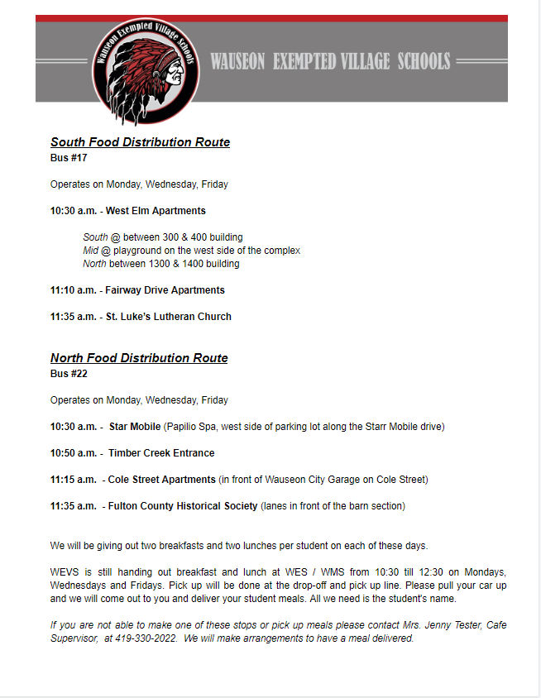**School Provided Lunches**



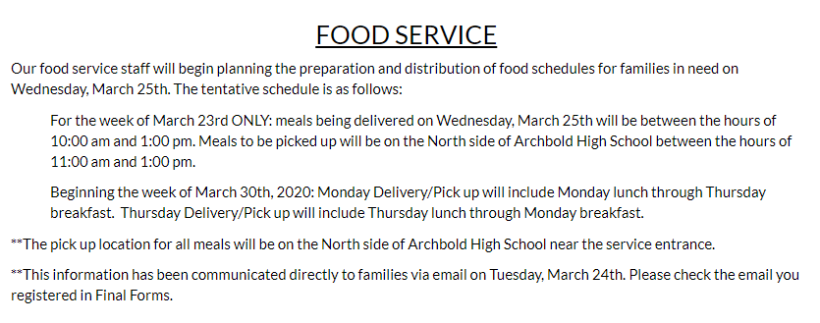

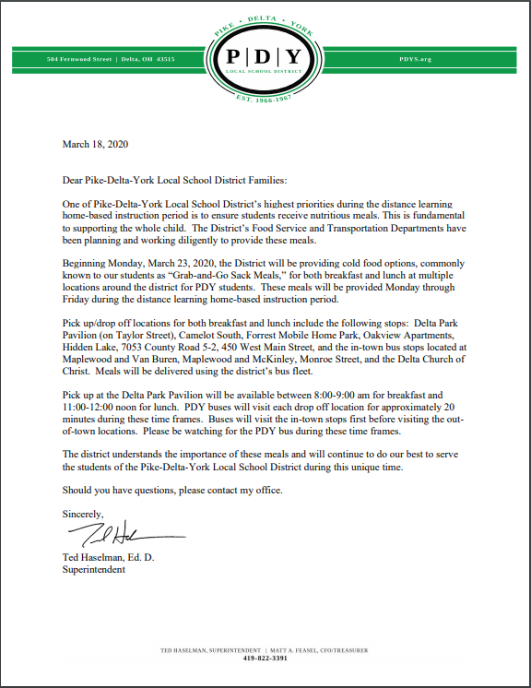



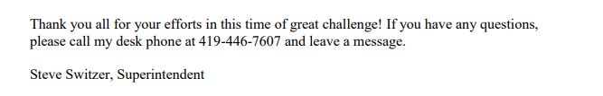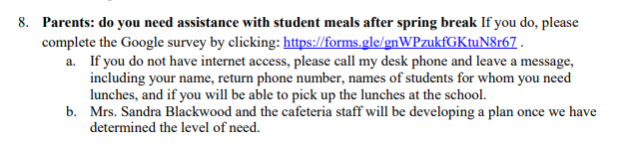



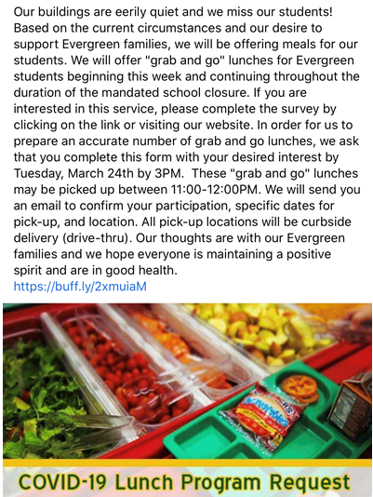

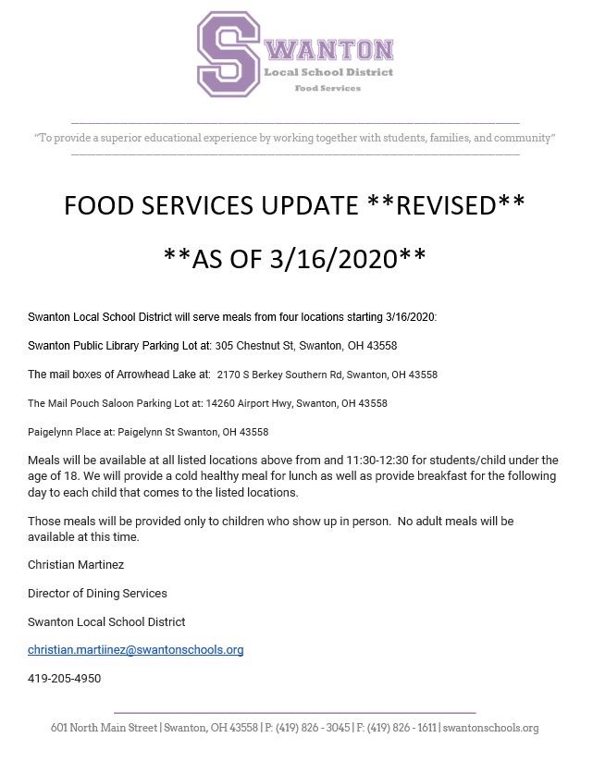

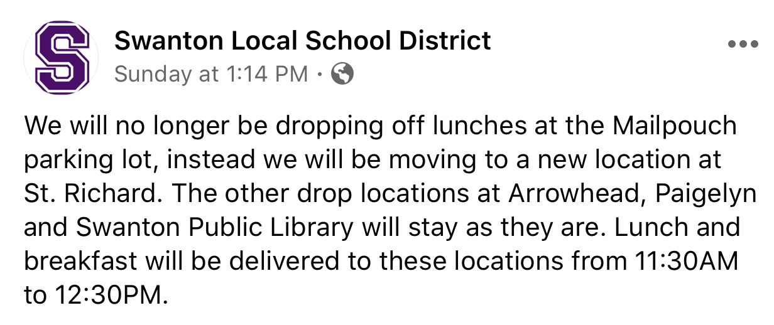

**Other Agencies offering services**

1. **NOCAC- Located at 604 S. Shoop Ave Suite 120 Wauseon OH 43567-** For HEAP, PIPP, Utility Assistance, Rental Assistance, and other emergency needs call 1-844-493-1193 to make an appointment. For emergency shelter & services to homeless people call 419-990-5135.
2. **Crossroads Evangelical Church – Located at 845 E Leggett St Wauseon OH 43567- (Wauseon, Archbold, Pettisville residents only)** Clients can call 419-335-3686 and leave message. Volunteers are available to pick up groceries and medicines for the Elderly or disabled who are not able to get out.
3. **United Way- Located at 604 S. Shoop Ave Suite 122 Wauseon OH 43567.** Clients can call 419-337-9606or email [unitedway@fultoncountyoh.com](mailto:unitedway@fultoncountyoh.com) Food vouchers can be mailed to families with food insecurities. ***This is all based on funding available.